How To Create Slideshows with the Free PhotoStory 3



Introduction
Photo Story 3 is freeware from Microsoft which runs only on Windows XP computers. Photo Story 3 automatically pans and zooms over still images. By adding titles, one’s own narration and background music, it is possible to create digital stories that celebrate life.

- Photo Story 3 consists of 5 steps:
1. Import pictures & arrange
2. Add optional titles
3. Add narration
4. Add background music
5. Save and share “digital story”

Starting a Photo Story 3 Project:

So how do you begin this easy and fun multimedia project? Since many people do not own any photo editing applications, Microsoft made it possible to perform basic photo editing tasks within Photo Story 3, using the action buttons under the monitor window. Photo Story allows for each story to have up to 300 pictures, which can be files with extensions .bmp, .dib, .eps, .gif, .jhif, .jpe, .jpg, .pcd, .pcx, .png, .psd, .rle, .tga, and .tif. Once your images are imported, you can arrange them on the Photo Story film strip in the order you want them to be displayed. Use the editing tools to edit, enhance, rotate, and crop your pictures. The following edits are possible within the program: correct color levels, correct red eye, rotate, remove the borders, auto crop, create captions and titles, narrate, animate, create transition, add music, save, and share.
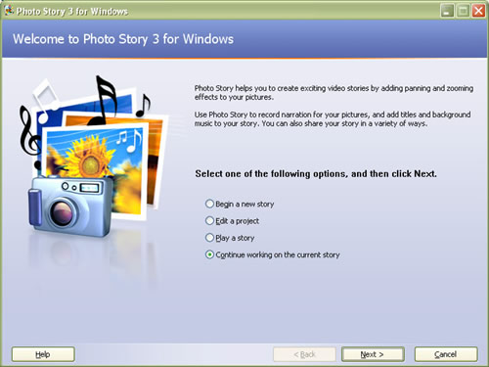
Step 1: Starting Photo Story 3 for Windows

- Start/Programs/Photo Story 3.
- Select “Begin a new story” & click “Next >” button.

Step 2: To Import and arrange your pictures:
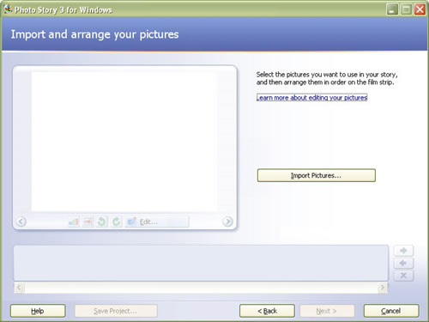
- Click “Import Pictures” & navigate to the folder where your images are stored.

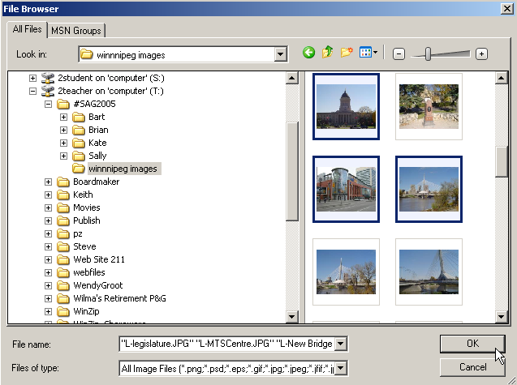
- Move “slider” at top right to adjust the size of thumbnails.

- Hold down the <Ctrl> key & click several thumbnail images including Portrait and Landscape formats.

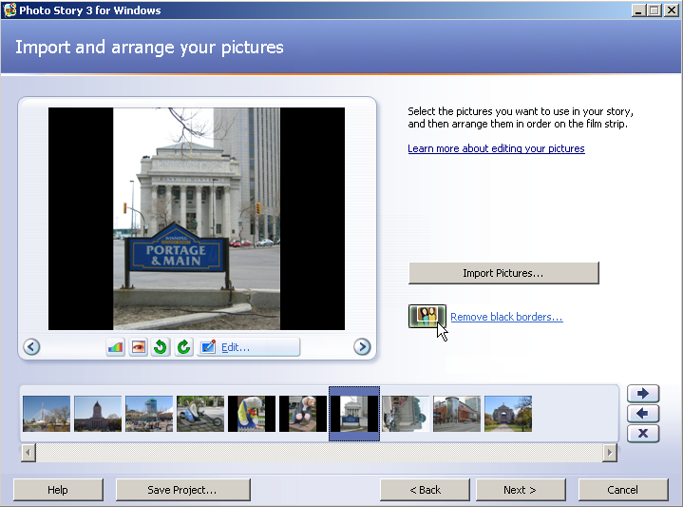
- Click “OK” button to import pictures into timeline. One can always import more pictures which will be added to end of current timeline.

- Drag images into different positions on timeline or use “arrows”.

- Drag all images in the timeline to their storytelling position.

- In the “Import and arrange your pictures” title section, note the editing tools below the preview screen. One can correct “color levels”, “red eye”, rotate & crop any displayed picture.

EDIT

One can click the “Edit” link, the “Add Effect” tab and select different effects including “Black and White”, “Negative”, “Outline”, “Water Color” etc. One can also add such effects in the “Add a title” segment as well.

Note: Photo Story 3 works best with images taken in a Landscape format. However, Portrait layout images can be used, by clicking the “Remove black borders” button. The software allows the user to define which portion of the Portraits shall be displayed. Click the” Remove black borders” button to experiment.

- Return to the “Import and arrange your pictures” timeline screen and click the “Save Project” button at the bottom. Give the file a name and navigate to the place where you want to save your PhotoStory3 .The file saves as an MP3 which can be modified and changed as required.

- Once the images are in their proper “storytelling” position, click the “Next >” button to proceed to adding optional titles.

Step 3: Adding a titles to your slides
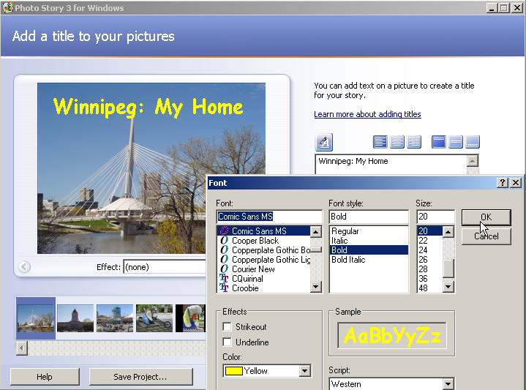
- On the Add a title to your pictures page, click a picture, and then type the title. If you want to change the appearance or location of the title, do the following:

- To change the font, click the Select Font button, and then select the font type, style, size, effects, color, and script you want to use.
- To change the horizontal alignment of the text, choose the Align Left, Center Horizontally, or Align Right button.
- To move the title up or down on the page, click the Align Top, Center Vertically, or Align Bottom button. By default, the title appears in the center of the picture.
- One may apply various “Effect:” options to selected images by choosing an effect at the bottom of the preview window.
- Once the title(s) are completed, click “Next >” button to move to the narration and customizing motion section.

Step 4: Adding Customize Motion and Narration
Make certain that the microphone and the speakers or headphones are properly connected and turned on.

- Select image #1 in the timeline and enter optional “cue card” notes.
  - e.g. “Welcome to Winnipeg located at the junction of the Red and Assiniboine Rivers.”
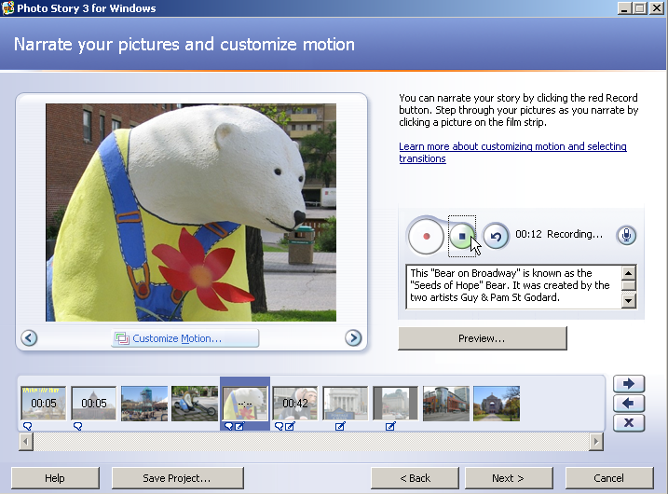
- Select another of the images. Enter on this image’s “cue card” an appropriate phrase such as:
  - e.g. “62 seven foot tall bears have been located along Broadway.”

- Repeat as needed.

- Return to slide #1, press the larger “Record Narration” button on the left, read from the cue card and press the smaller “Stop Recording” button in the middle.

- Repeat this process to add narration to selected slides.

- Click the “Preview …” button early, to make certain that you are properly positioned in front of the microphone and that your narration is clear. Close the preview screen by clicking the “X” in the top right corner.

- If the narration for a slide is poor or flubbed, select the slide in the timeline, click the right-hand “Delete Narration” button and try recording once more.

Customizing Motions is a unique feature of panning in and out of your images. By default motions as applied to your pictures but if you would like you may customize them. It works best it you use sparingly for a purpose.
e.g. time lapse or a dramatic shift of scene.

- To begin to customize your motions select the Customize Motion button.
- From the Motion and Duration tab, click Specify Start and End position of motion. Two copies of your image will be presented. The first one is titled Start position: and the second identical image End position: Both images will have a box that can be repositioned by dragging the resize handles.

- If you would like your image to show the full view then zoom in to a specific spot, you would leave the Start Position image as is and adjust the size and position of the box on the second image to suit.

- Once you are happy with your choice, select Save and then Close.
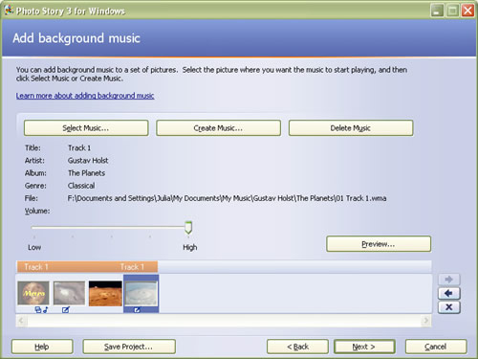
Step 5: Adding background music to your story
Adding background music that plays during your story is one way to enhance your lesson. A different piece of music can play for each picture or for a group of pictures. The Select Music option lets you choose a piece of music from your computer, a network folder, or the Internet. The Create Music option lets you customize prerecorded pieces and styles of music by selecting the genre, style, bands, mood, tempo, and intensity of the music.

Note: Remember that the addition of audio components to any multi-media project increases the file size dramatically.

- Select an image from the timeline where you want the background music to be introduced. Usually this is the first picture in your PhotoStory.

- If you click “Select Music” button, one can add one’s own LEGAL Windows Media Audio (WMA), MP3 or WAV files.

- Or if you select the Create Music button with the Genre set to “All”, click the “Style” drop down list box to display a range of royalty-free music including: Classical, Country, Dance, Funk, Jazz, Latin, New Age, Pop, Rock or Silence (when one wants to insert “silence” on slides in the middle of a background musical selection).

- Click a Style, Band and Mood.

- Click the “Play” button at the bottom and adjust the Tempo and Intensity.

- Continue to modify the music properties while gaining audio feedback by using the “Play” button.

- When the background music is finalized, click the “OK” button to see that a music bar is added above the timeline.

- Adjust the “Volume” slider to about 30% - 40% so that the background music does not overpower one’s narration.

- Click the slide where you want to begin and click the “Preview” button to see and hear how well-balanced the narration and background music are in your digital story.

- Close the preview screen by clicking the “X” in the top right.

- When satisfied, click “Save Project” button once again.

- Click the “Next >” button to move to the last section to “Save your story”.

- To select the music for your story, select a picture. Then select a piece of music to start playing when the picture is displayed in your story. The picture you select is the anchor image, and indicates where you want the music to start playing. This is usually the beginning of your PhotoStory. The anchor image is indicated by a musical note displayed beneath the picture in the film strip. The music you select plays until one of the following events occurs:
  - The music ends.
  - An anchor image that specifies a new piece of music be played is encountered.
  - The story ends.
You can replace a piece of music for an anchor image by selecting a different piece of music or by dragging a music file onto the anchor image in the film strip.

NOTE: If the anchor image is deleted from the story, the music and any other customizations associated with the anchor image are also deleted from the story.
When you add background music to your story, a music strip appears above the film strip. The music strip displays the name of each piece of music that is added to your video story. The music strip is color-coded for each piece of music in the story. Photo story automatically adjusts the amount of time a piece of music will play in your story when any of the following occurs:
  - A picture is added to a group of pictures.
  - A picture is deleted from a group of pictures.
  - A picture is moved to a different place in the story.
  - Another piece of music is added to the story.
  - The story ends.

Step 6: Save your story
This screen asks you “What do you want to do with your story?”
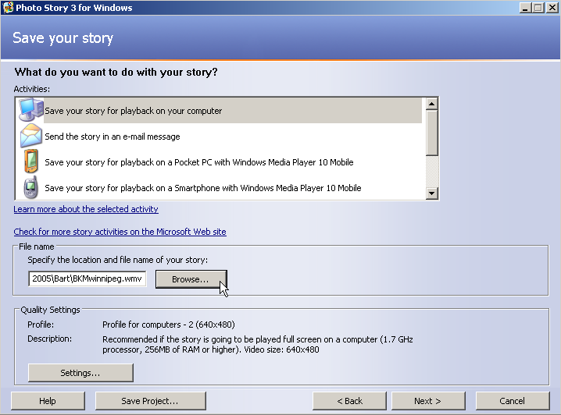


- To save an unfinished project for more editing later, click “Save the project” and then choose where you want to save the file. Then your story remains on file to be edited another time. It saves with this icon.


- To make your finished PhotoStory Video Clip, choose -Save your story for play back on your computer. This option converts your graphics, music and voice into a Video Clip. This should be the finished product. It cannot be edited. It will look like this.

- Under File Name, click the Browse button. It is recommended that you save your project in the same folder with your images and sound clips.
- Name your file and click OK
- Click the “Settings” button to make gain information about the “Profile” (e.g. Profile for computers 2 – (640 x 480)), “Details” and “Story file size”. Click “OK” to proceed.
- Click the Next button. Your PhotoStory will generate and you will then be prompted to view your story. Be patient as the computer compiles the elements into a movie using a four step process:
Step 1 - Preparing video; Step 2 - Generating Custom Music;
Step 3 - Mixing audio; and Step 4 - Generating video

Step 7: Viewing your story

When your story is built and saved, the Completing Photo Story 3 for Windows page will appear. You can view your newly created story or begin a new story from here.

- To see what you have created, click View your story. Windows Media Player will open and your story will begin to play.
Strengths of Photo Story 3 in the Classroom:

- Very easy to use
- Inexpensive
- Cool Pan and Scan

Weaknesses of Photo Story 3 in the Classroom:
- Jerky zooms (Images can be pixely)
- Narration is per image

Summary
Photo Story 3 is a quick, easy fun way to transform your still photos into moving slide shows for playback over the Web, in DVD players, in PowerPoint presentations and more. Resources and Citations

Photo Story
(http://www.microsoft.com/windowsxp/using/digitalphotography/photostory/default.mspx)
The latest version of Microsoft's Photo Story makes creating video slideshows a breeze and amongst all the new features one stands out from the crowd - it is now FREE!

Image Resizer (www.microsoft.com/windowsxp/downloads/powertoys/xppowertoys.mspx)
Microsoft has a range of useful Powertoy applications available for FREE download for Windows XP.

The Digital Camera in Education
(http://www.drscavanaugh.org/digitalcamera)

Digital Storytelling
http://visalia.k12.ca.us/teachers/mblanton/Techcoach/photostory/

