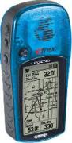

This certificate is given to:

In recognition of
completing the
GREAT GEOCACHE
logic puzzle race at
Bayshore Elementary!

Mrs. Taylor
May 2008

