Upriver Peace River Talk
Tour Itinerary
April 16, 2008

7:30 Meet at Winn-Dixie at 27680 Bermont Road
7:45 Depart for south fort meade (pretest and videos on bus)
9:15 Arrive at phosphate mine
11:30 Transit to lunch
12:00 Lunch at mining restoration site
12:30 Transit to South Florida Community College
1:00 Arrive at South Florida Community College for citrus talk
2:00 Transit to Paynes Creek State Park
2:30 Arrive at Paynes Creek State Park
3:30 Depart for Punta Gorda (posttest and wrap-up)
5:15 Arrive Punta Gorda

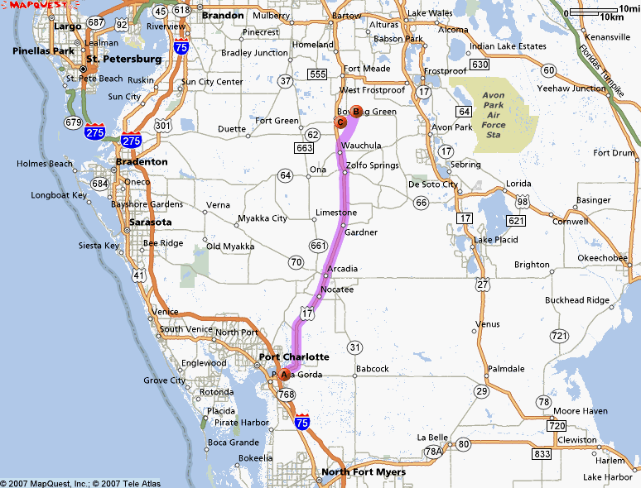

This tour is sponsored by the Charlotte Harbor Environmental Center
and the Manasota and Peace River Basin Boards of the
Southwest Florida Water Management District

