Senior Software Engineering Project
CSSP Project
CEN 4935

Software Requirements Specification
Draft as of April 5, 2006

Adam Cox
Tass Oscar
1. Introduction
One of the ways in which social worker professionals and students evaluate their clients is with questionnaires and surveys provided by the Walmyr Publishing Company^{[1]}. The surveys, given weekly, are used to evaluate their clients in a variety of emotions including contentment^{[2]}, stress^{[3]}, and self-esteem^{[4]}. Data acquired from these questionnaires must be translated into a visual chart to be placed in the client’s file. This chart is used by medical personnel to evaluate the effectiveness of any treatment given to the client.

2. Problem Description
Note: The figures shown in the requirements below are examples. The actual implementation screens may differ slightly.

2.1 Functional Requirements
2.1.1 Upon starting, the program shall display a welcome screen summarizing its basic functionality and a prompt to either continue or exit.
2.1.2 If the operator chooses to exit, then the program shall close.
2.1.3 If the operator chooses to continue, then the program shall display the client profile load screen as presented in figure 2.1.3.
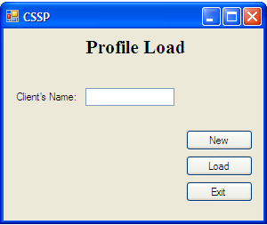
Figure 2.1.3

2.1.4 On the screen, the operator will create a new client profile, load an existing client profile, or exit the program.
2.1.5 If the operator chooses to create a new client profile from Req. 2.1.4, then the program shall display the profile creation screen as shown in figure 2.1.5.
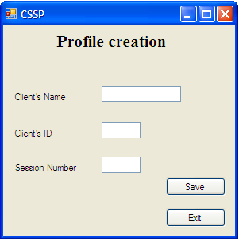
Figure 2.1.5

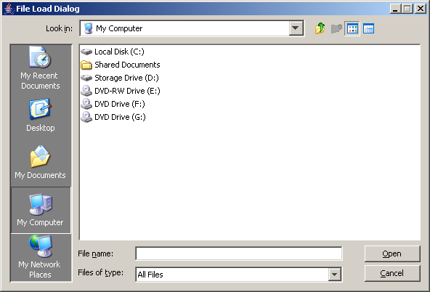
2.1.6 If the operator chooses to load an existing client profile from Req. 2.1.4, then the program shall display an open file dialog as shown in figure 2.1.6.
Figure 2.1.6
2.1.7 If the operator chooses exit from Req. 2.1.4, then the program shall close.
2.1.8 Once a profile is selected the program shall display the client information screen as shown in figure 2.1.8.
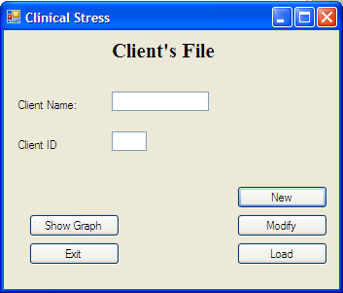
Figure 2.1.8

2.1.9 The client information screen presents the following options:
a) Enter new session data
b) Modify old session data
c) Display data graph.
d) Load another profile.
e) Exit

2.1.10 If the operator chooses option (a) from Req. 2.1.9, then the program shall display the data entry screen as shown in figure 2.1.10.

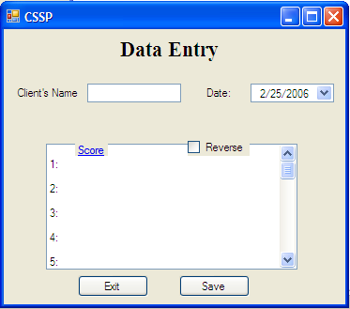
Figure 2.1.10

2.1.11 After entering the data into the form the program shall prompt the operator to verify the data integrity.
2.1.12 Upon verification by the operator, the program shall save the data into the client’s profile.
2.1.13 If the operator chooses option (b) from Req. 2.1.9, then the program shall present a list of the sessions already entered in the client profile.
2.1.14 Once a specific previous session has been chosen by the operator, the program shall display the data entry screen for that session for possible modification.
2.1.15 Once modifications are complete, the program shall prompt the operator to verify the data.
2.1.16 Upon verification by the operator, the program shall now save the modified data.
2.1.17 If the operator chooses option (c) from Req. 2.1.9, then the program shall show a graph depicting the client’s progress as presented in figure 2.1.17. The program shall also display an option to print the graph.

Figure 2.1.17

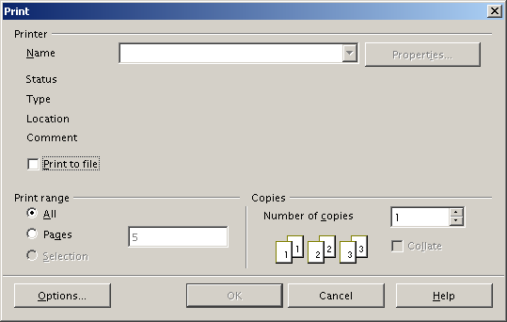
2.1.18 If the operator chooses to print the graph, then the program shall display a print dialog box as shown in figure 2.1.18.
Figure 2.1.18

2.1.19 If the operator chooses option (d) from Req. 2.1.9, then the program shall display the profile load screen as detailed in Req. 2.1.3.
2.1.20 If the operator chooses to exit the program, then the program shall close.

2.2 Security Requirements
2.2.1 Since the program handles medical information, the data shall at least be password protected.
2.2.2 Additional security requirements to be determined by operator.
Currently, there is no standard method to handle the questionnaire data and create charts. Walmyr offers survey assessment software for sale online, but it costs $60 per copy and does not feature chart creation functionality. Another option is to use spreadsheet software like Microsoft Excel to store the data and generate the charts, but not all users have the skills necessary to operate this type of software. Also, each user may input their data into the spreadsheet differently. Without a standard template, sharing data becomes confusing as one social worker must decipher another’s data.

3. References
- Walmyr Publishing Company, http://www.walmyr.com/
- Generalized Contentment Scale (GCS), http://www.walmyr.com/GCSSAMPL.pdf
- Index of Clinical Stress (ICS), http://www.walmyr.com/ICSSAMPL.pdf
- Index of Self-Esteem (ISE), http://www.walmyr.com/ISESAMPL.pdf

*** End of Software Requirements Specification ***

